# Business Challenge

Contact Centers are managing more channels, while channel management is getting increasingly complex, and customers are dissatisfied with channel experiences. Agents must respond to a variety of questions, using many disparate data sources to find the insights needed for complex questions. Keeping content sources and agents up to speed is critical to success. *Especially relevant for Financial Services, Telecommunications, Energy& Utilities, Insurance, Airline, and Media companies.*

# Watson inspired solution to the problem

The Watson Agent Assist solution pattern can integrate disparate data and content sources to compile a 360-degree profile of a customer including transactions and behavior. Agents will be able to use the search and analytics functionality of Watson to get precise information from the organization’s data lake.

# Client discussion points Do your agents spend considerable amount of time searching documents for answers, attempt multiple troubleshooting paths on the same call, and touch numerous systems to resolve customer issues?

* Do your agents receive recommendations and trends revealed across all customer engagement channels?
* Would your agents benefit from quick access to relevant, personalized information to provide a higher quality of customer care?
* How would customers rate their current experiences with your call center agents?
* How does the performance of recently hired agents compare to those with experience in your call center and with your customers?

Qualification Checklist

* What level of client sponsorship exists for this opportunity?
* Does the client have a transformational vision?
* Does the client have budget to spend?
* What are the call center metrics that the client cares about the most and what impacts are being viewed?
* Does the client have high churn for the call center agents?
* By what amount is the client targeting the improvement of NPS?

# Client Evaluation

**What is the client buying?**

* A 1-year subscription to Watson Explorer license and Watson Developer Cloud Platform to enable the client to develop the Social CRM pattern

**How much does it generally cost and timeline?**

* $250K for 1-year subscription & 4 weeks to deploy an initial pilot

**How does the solution get implemented?**

* There are two options:
* Self-Serve: 1-week enablement session for client developers with education on the solution pattern. After which, client IT teams then develop/deploy the solution in a self-serve mode.
* Professional Services: Leverage IBM or a systems integrator to develop
* [Agent Assist Demo](https://vanguard-cca-app.mybluemix.net/pages/main.html)

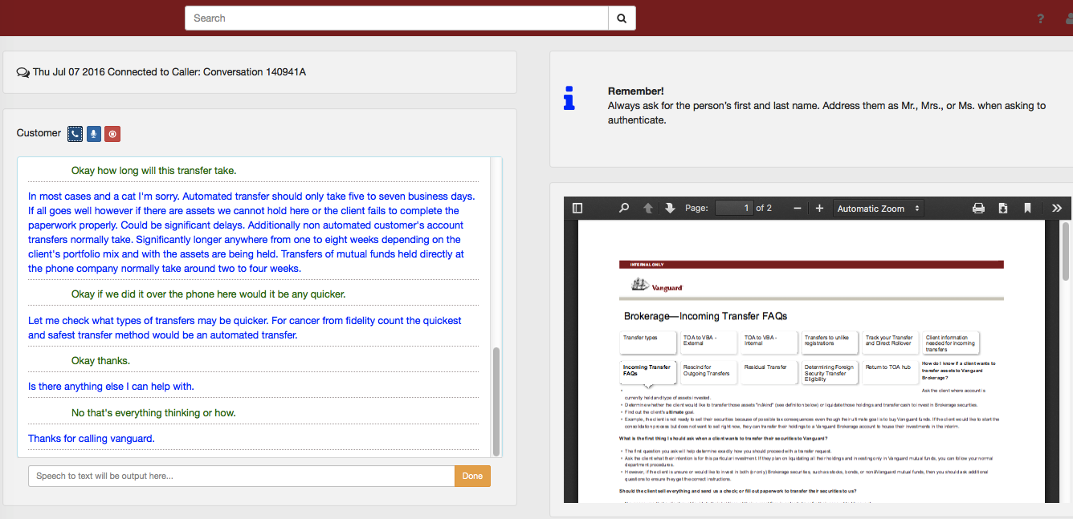KPI’s impacted

* Decrease AHT
* Decrease transfers
* Increase First Call resolution
* Increase revenue through cross sell and up sell opportunities
* Consistency of answers across agents
* Decrease agent turnover
* Increase Next Call Prevention
* Increase Net Promoter Score (NPS)

# Target Buyer

* VP Call Center
* CRM Leaders

## Competitive Differentiation

* Clients struggle to do this one their own given the complexity of developing a profile of a customer or entity based on all the disparate sources of data that the organization has. Watson is uniquely differentiated such that it can serve as the platform that brings together all these forms of structured and unstructured data to reveal insights for the agent.

|  |  |  |
| --- | --- | --- |
| Agent Assist |  | Contact – Owen Coelho – occoelho@us.ibm.com |